**The impact of liquidity, return on assets, and company growth on stock prices in Manufacturing Companies listed on the Indonesia Stock Exchange**

T.F Bastian Sitorus1, Mas Intan Purba1, Winda Novalina Br Simbolon1, Monika E. Siregar1, Nur Aliah2

1Prima Indonesia University

2Pembangunan Panca Budi University

Corresponding Author: [masintanpurba84@gmail.com](mailto:masintanpurba84@gmail.com)

Received: 2 May 2023

Accepted: 8 June 2023

DOI: 10.55942/jebl.v3i3.208

Abstract

The purpose of this study is to determine the effect of liquidity, return on assets, and company growth on stock prices in manufacturing companies for the period 2018–2021. The population of this study consisted of 42 companies, and the sample consisted of 17 companies, which included manufacturing companies listed on the Indonesia Stock Exchange for the period 2018-2021. In this study, the researcher used a quantitative method with multiple linear regression analysis tools. The research data consisted of numbers that would be measured using statistics as a calculation test tool, related to the problem under study to generate a conclusion. Therefore, it can be concluded that liquidity partially has a negative and insignificant effect on stock prices. Return on assets partially has a positive and significant effect on stock prices. And company growth partially has a positive and significant effect on stock prices. And the magnitude of liquidity, return on assets, and company growth on stock prices is 47.8 %.

Keywords: Liquidity, Return on Asset, Company Growth, Stock Prices

1. **Introduction**

A manufacturing company is a company that carries out the process of creating a product. A company can be classified as a manufacturing company if there are input-process-output stages for its final product production. Manufacturing is an industrial branch that applies equipment and processing media to transform raw materials into finished products for sale. This work involves all the processes necessary for production and integration of product components. There were 232 manufacturing companies listed on the Indonesia Stock Exchange (IDX) in 2021. Some examples of manufacturing companies listed on the IDX include, but are not limited to: Gudang Garam (GGRM), Indo Food Sukses Makmur (INDF), Sido Muncul (SIDO), Garudafood Putra Putri Jaya (GOOD).

A company's value is a specific condition achieved by a company as a reflection of public trust in the company after undergoing a process of operational activities since the company was established (Fahlevi et al., 2022). The value of a company can be seen from the company's share price (Yusuf et al., 2023). The share price is the price set for a company for other parties who want to own shares. The share price is always changing. The share price is influenced by sellers and buyers of shares. The rise and fall of share prices in the capital market is proportional to the performance of a company (Sahabuddin et al., 2023). The share price determines the wealth of shareholders so its information is important for investors in the capital market. Some factors affecting the value of shares, among others: Liquidity, Return on Asset (ROA), and Profitability (Meiryani et al., 2023).

Generally, liquidity is defined as the ability to meet cash flow needs promptly and at a suitable cost, where the general function of liquidity is first: to carry out daily business transactions (Hussain et al., 2023), second: to meet urgent funding needs, and third: to meet customer loan requests and provide flexibility to seize attractive and profitable investment opportunities. According to the Great Dictionary of the Indonesian Language, the definition of liquidity usually knows a company's cash position and its ability. Liquidity management is an issue related to a company's ability to meet financial obligations that must be fulfilled immediately. The amount of payment instruments (liquid notes) owned by a company at a certain time represents the company's ability to pay.

Return on Assets (ROA), a financial ratio used to measure a bank's profitability. Return on assets is used to measure a bank's financial performance to ensure whether the bank is healthy or not. The bank's profitability must be carried out transparently and accountably, prioritizing the health of the banking system itself to gain public trust in banking. Asset return is a ratio of net income after tax divided by the average assets at the beginning and end of the period, and measures the company's ability to manage the value of each asset it owns (Ahmed et al., 2023). Below is a table of phenomena on liquidity, return on asset, company growth, and stock prices of food and beverage sector manufacturing companies for the period 2018 to 2021:

**Table 1. Financial Report on Manufacturing Companies (2018 – 2021)**

|  |  |  |  |  |  |
| --- | --- | --- | --- | --- | --- |
| **Company (Code)** | **Year** | **Liquidity** | **ROA** | **Growth** | **Stock Price** |
| GOOD | 2018 | 1,1825 | 0,1010 | 0,1819 | 1,875 |
| 2019 | 1,5338 | 0,0861 | 0,2019 | 1,625 |
| 2020 | 1,7512 | 0,0373 | 0,2978 | 1,270 |
| 2021 | 1,4754 | 0,0728 | 0,0143 | 525 |
| ULTJ | 2018 | 4,3981 | 0,1263 | 0,0734 | 1,350 |
| 2019 | 4,4441 | 0,1567 | 0,1894 | 1,680 |
| 2020 | 2,4034 | 0,1268 | 0,3247 | 1,600 |
| 2021 | 3,1126 | 0,1724 | -0,1539 | 1,570 |
| STTP | 2018 | 1,8485 | 0,0969 | 0,1233 | 3,750 |
| 2019 | 2,8530 | 0,1675 | 0,0925 | 4,500 |
| 2020 | 2,4050 | 0,1823 | 0,1969 | 9,500 |
| 2021 | 4,1649 | 0,1576 | 0,1363 | 7,550 |

*Source: www.idx.co.id (data processed by the researcher, 2022)*

Based on the phenomenon table, it can be seen that the data above fluctuates. The phenomenon in liquidity that occurred in PT. Garudafood Putra Putri Jaya Tbk (GOOD), experienced an increase in 2018 - 2019 and was inversely proportional to the stock price which decreased. The phenomenon in the return on assets at PT. Ultra Jaya Milk Industry & Trading Company Tbk (ULTJ), increased in 2020 - 2021, inversely proportional to the stock price which decreased. The phenomenon in company growth experienced a decrease in PT. Siantar Top Tbk (STTP) was inversely proportional to the stock price which increased in 2018 – 2019.

1. **Literature Review**

**Liquidity**

Liquidity is the company's ability to meet short-term financial obligations on time or the company's ability to provide cash or cash equivalents, as shown by the size of current assets, i.e., assets that are easily converted into cash, which includes cash, securities, receivables, inventory. The formula for Liquidity is:

**Return on Asset (ROA)**

ROA or more commonly known as the return on assets is a ratio that describes the result of the total assets used in the operation of a company. The return on assets shows how productive the company is in utilizing all company funds, whether in the form of borrowed capital or the company's own capital.

**Company Growth**

Company growth is expressed as the growth of total assets where past asset growth will depict future profitability and growth. Growth is the impact on the company's cash flow from operational changes caused by growth and a decrease in business volume.

**Research Model**

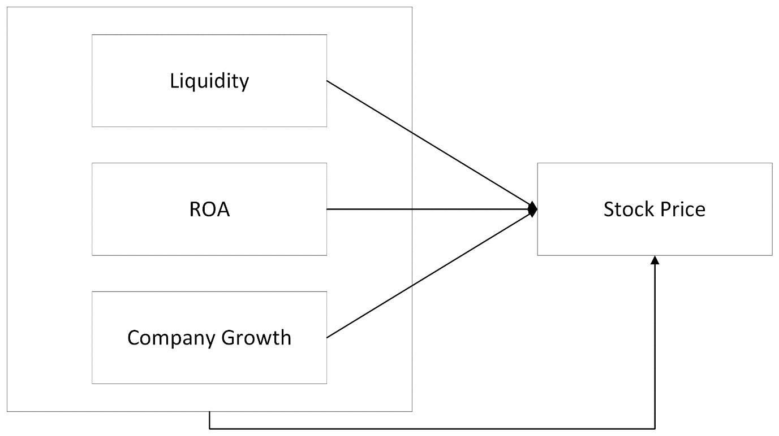

**Figure 1. Research Model**

**Hypotheses**

* H1: Liquidity has a significant effect on the stock prices of manufacturing companies listed on the Indonesia Stock Exchange during the period 2018–2021.
* H2: Return on Asset has a significant effect on the stock prices of manufacturing companies listed on the Indonesia Stock Exchange during the period 2018–2021.
* H3: Company Growth has a significant effect on the stock prices of manufacturing companies listed on the Indonesia Stock Exchange during the period 2018–2021.
* H4: Liquidity, Return on Asset, and Company Growth collectively have a significant effect on the stock prices of manufacturing companies listed on the Indonesia Stock Exchange during the period 2018–2021.

1. **Methodology**

The research was conducted on manufacturing companies in the food and beverage sub-sector listed on the Indonesia Stock Exchange during the period 2018–2021. The research period was from June 2022 to December 2022. This research uses a quantitative approach technique. Quantitative research is research with analysis that depicts the condition of the company based on the obtained quantitative data. The type of research used in this study is descriptive quantitative research (Meiryani et al., 2023). According to Sugiyono (2015), causality associative research is research that aims to determine the cause-and-effect relationship between two variables or independent variables and dependent variables. In this research, the dependent variable is the stock price, while the independent variables are liquidity, return on assets, and company growth.

The population used in this research comes from manufacturing companies in the food and beverage sub-sector listed on the Indonesia Stock Exchange for four years during the period 2018–2021, with a total of 42 companies. The sample selection uses purposive sampling technique, which means the sample used in the research is a sample that meets certain criteria according to the purpose of the research. The criteria used to select the sample are as follows:

1. Companies that were listed on the Indonesia Stock Exchange in the food and beverage sub-sector in 2018–2021.
2. Companies that are listed on the Indonesia Stock Exchange and consistently publish financial reports during the period 2018–2021.
3. Companies that have made profits during the period 2018–2021.

The research sample obtained is 17 manufacturing companies listed on the Indonesia Stock Exchange during 2018 – 2021. The determination of this research sample was done by using the criteria outlined in the following table:

**Table 2. Criteria Selection**

|  |  |  |
| --- | --- | --- |
| **No** | **Criteria** | **Total** |
| 1 | Companies listed on the Indonesia Stock Exchange from 2018–2021. | 42 |
| 2 | Companies listed on the Indonesia Stock Exchange and are inconsistent in publishing financial reports during the period 2018–2021. | (18) |
| 3 | Companies that experienced losses during the period 2018–2021. | (7) |
| Total Company Sample | | 17 |
| **Total Sample 17 X 4 Years** | | **68** |

The research was conducted on manufacturing companies in the food and beverage subsector listed on the Indonesia Stock Exchange during the period 2018–2021. This research employed a quantitative approach, making use of secondary data sources including official websites like the Indonesia Stock Exchange (BEI) at [www.idx.com.id](http://www.idx.com.id/) and IDN Financial at idnfinancials.com/id/ from 2018 to 2021. Data collection was done through documentation, consisting of the list of all researched companies and audited financial report data found through the official website of the Indonesia Stock Exchange ([https://www.idx.co.id](https://www.idx.co.id/)).

Three classical assumption tests were conducted: Normality, Multicollinearity, and Autocorrelation. The Normality test aimed to check whether the residuals in the regression model were normally distributed or not. The Multicollinearity test, as per Ghozali (2018), was used to identify if there was any perfect relationship among independent variables in the regression model. Lastly, the Autocorrelation test was to check for any correlation between disturbance errors in the linear regression model.

The research analysis method included the use of SPSS to perform statistical analysis procedures. The study employed multiple linear regression as it allowed observation of the coefficient size or relationship between independent and dependent variables. The model regression applied was as follows: 𝑌1 = 𝑎 + 𝑏1𝑋1 + 𝑏2𝑋2 + 𝑏3𝑋3 + 𝑒 Where: Y = Stock Price a = Constant b1…b4 = Regression Coefficients X1 = Liquidity X2 = ROA X3 = Company Growth e = Standard error

The coefficient of determination essentially showed how far it can explain the variation of the dependent variable. The use of a small R value indicates the limited ability of the dependent variable. A value near one means the independent variables provide almost all the information needed to predict the dependent variable's variation. The study employed the F-test, according to Ghozali (2015), to determine whether all independent variables included in the model influenced the dependent variable simultaneously or not. The partial t-test, as per Ghozali (2020), was used to show the effect of independent variables on the dependent variable, considering other independent variables constant. The methods of hypothesis testing were also laid out in detail, providing specific criteria for acceptance or rejection of hypotheses.

1. **Result and Discussion**

**Descriptive Statistics**

Descriptive statistics is a segment of statistics that is useful for collecting and communicating data in an easily understandable manner. The purpose of descriptive statistics is to represent a condition or occurrence. Descriptive statistics can be derived from the minimum, maximum, average, and standard deviation of a research sample. The descriptive analysis can be seen as follows: Table 3.1 Descriptive Table

**Table 3. Descriptive Statistics**

|  |  |  |  |  |  |
| --- | --- | --- | --- | --- | --- |
| **Variables** | **N** | **Minimum** | **Maximum** | **Mean** | **Std.iDeviation** |
| Liquidity | 68 | .73190 | 13.30910 | 3.0744941 | 2.87176903 |
| ROA | 68 | .00050 | .42390 | .1006897 | .07845356 |
| Growth | 68 | -.17080 | 1.67610 | .1139353 | .24016056 |
| Stock Price | 68 | 96.00000 | 16000.00000 | 3201.6176471 | 3749.76688640 |

Table 3 shows the minimum value, maximum value, average, and standard deviation of the liquidity variable (X1), return on asset (X2), company growth (X3), and stock price (Y) as follows: The liquidity variable based on the total sample from manufacturing companies listed on the Indonesia Stock Exchange of 68 samples has a minimum value of 0.73190, a maximum value of 13.30910, a mean value of 3.0744941, and a standard deviation of 2.87176903. The Return on Asset variable based on the total sample from manufacturing companies listed on the Indonesia Stock Exchange of 68 samples has a minimum value of 0.00050, a maximum value of 0.42390, a mean value of 0.1006897, and a standard deviation of 0.07845356. The Company Growth variable based on the total sample from manufacturing companies listed on the Indonesia Stock Exchange of 68 samples has a minimum value of -0.17080, a maximum value of 1.67610, a mean value of 0.1139353, and a standard deviation of 0.24016056. The stock price variable based on the total sample from manufacturing companies listed on the Indonesia Stock Exchange of 68 samples has a minimum value of 96.00000, a maximum value of 16000.00000, a mean value of 3201.6176471, and a standard deviation of 3749.76688640.

**Classic Assumptions Test**

*Normality*

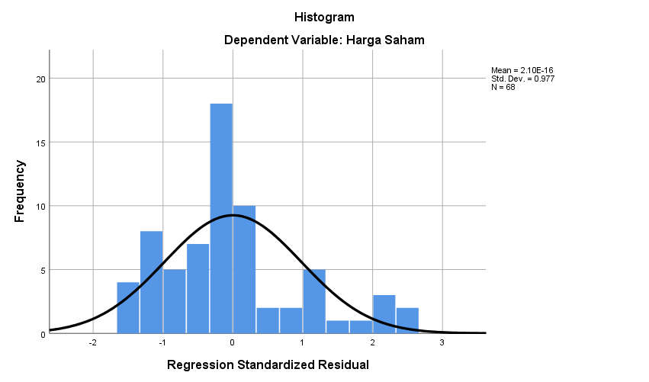

**Figure 2. Graphical Analysis for Normality Test**

*(Data Processed in SPSS 2023)*

In the histogram plot above, it can be seen that the data is normally distributed because the histogram plot shows a distribution pattern that is not skewed left and right. It can also be observed that the diagonal divides both sides symmetrically with respect to the histogram, thus it can be concluded that the data is normally distributed. In addition to the histogram plot used to define the normal distribution of data, it can also be observed from the normal probability plot in the image below: B. Normal Probability Plot Graph

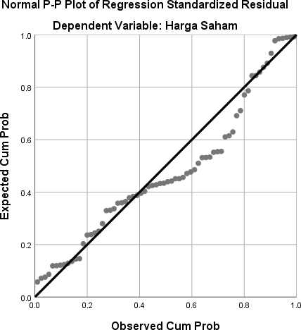

**Figure 3. Graphical Analysis of Normality P-Plot**

*(Data Processed in SPSS 2023)*

In the above Figure, the normality probability plot graph shows that the points are between the diagonal line and follow the line. It can be concluded that the probability plot graph is normally distributed. Therefore, the data has been normally distributed because the results of the normality test, the histogram graph, P-P Plot and Kolmogorov_Smirnov have met the normal assumption signs. To have research data normally or not distributed, the researcher then conducted a normality test. The normality test method, the nonparametric statistic of Kolmogorov_Smirnov Test used by the researcher can be seen as follows:

**Table 4. Kolmogorov-Smirnov Statistics**

|  |  |  |
| --- | --- | --- |
|  | | **UnstandardizediResidual** |
| N | | 68 |
| NormaliParametersa,b | Mean | .0000000 |
| Std.iDeviation | 2647.47771114 |
| MostiExtremeiDifferences | Absolute | .164 |
| Positive | .164 |
| Negative | -.068 |
| TestiStatistic | | .164 |
| Asymp.iSig.i(2-tailed) | | .000c |

*(Data Processed in SPSS 2023)*

Based on the results of the Kolmogorov-Smirnov test, the Asymp. Sig value is 0.000 which is less than 0.05. We can see that this may indicate that the data is not normally distributed and the regression is not suitable for predicting the dependent variable value of the company according to the input of independent variables, which are liquidity, return on assets, and company growth.

**Multicollinearity**

Based on the result, it can be noted that the tolerance value of the variables in sequence: liquidity, return on assets, company growth is greater than 0.10, while the VIF value of the liquidity variable (X1) is 1.030, return on assets (X2) is 1.001, and company growth (X3) is 1.029, less than 10. Thus, these three independent variables do not have multicollinearity issues. If the VIF value is less than 10, there is no multicollinearity disturbance, but if the VIF value is greater than 10, a multicollinearity disturbance occurs.

**Heteroskedasticity**

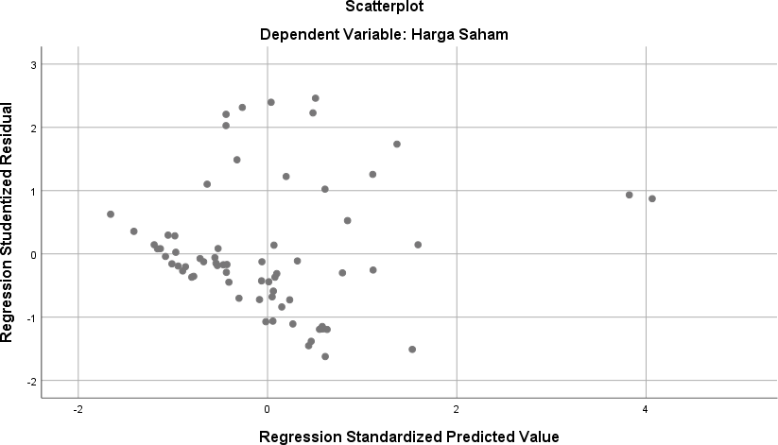

**Figure 4. Scatterplot**

From Figure 4 the Scatterplot showing the heteroskedasticity test against the dependent variable shows that the points are spread evenly and well both above and below the number 0 on the Y-axis. It can be concluded that there is no heteroskedasticity occurring in the regression model.

**R Square**

The Determination Coefficient (Adjusted R Square) is 0.478. This means that the variable selection is influenced by the liquidity variable, return on asset, and company growth by 47.8%. The remaining 52.2% is explained by other factors outside of this study. Based on the F-value of 21.463, which is greater than the F-table value of 2.75, the study accepts H4. This indicates that there are effects of liquidity, return on assets, and company growth simultaneously on the stock price.

**Multiple Linier Regression**

**Table 5. Coefficients**

|  |  |  |  |  |  |
| --- | --- | --- | --- | --- | --- |
| **Model** | | **t** | **Sig.** | **CollinearityiStatistics** | |
| **Tolerance** | **VIF** |
| 1 | (Constant) | .590 | .557 |  |  |
| Liquidity | -1.902 | .062 | .971 | 1.030 |
| ROA | 7.461 | .000 | .999 | 1.001 |
| Growth | 1.999 | .050 | .971 | 1.029 |

(H1) It is known that the Sig value to influence liquidity against the stock price is 0.062 > 0.05 and the t-calculation value is -1.902 < t-table 1.998. Therefore, it can be concluded that liquidity partially negatively and insignificantly affects the stock price. (H2) It is known that the Sig value to influence the return on assets against the stock price is 0.000 < 0.05 and the t-calculation value is 7.461 > t-table 1.998. Therefore, it can be concluded that the return on assets partially positively and significantly affects the stock price. (H3) It is known that the Sig value to influence the company's growth against the stock price is 0.047 < 0.05 and the t-calculation value is 1.999 > t-table 1.998. Therefore, it can be concluded that the company's growth partially positively and significantly affects the stock price.

**Discussion**

*Liquidity Impact on Stock Price*

The research results show that liquidity partially negatively and insignificantly affects the stock price, with the Sig value to influence liquidity against the stock price is 0.062 > 0.05 and the t-calculation value is -1.902 < t-table 1.998. In general, the larger the company's liquidity, the higher the stock price because it indicates the company's ability to meet its operational needs, especially working capital which is very important for maintaining the company's performance. However, this study shows the opposite because the liquidity value in the studied company is quite low, thus showing a tendency for a negative influence of liquidity. This research is in line with previous research by Ilyasa (2016) titled the influence of liquidity, activity, and profitability on stock returns in manufacturing companies listed on the IDX in 2010-2013. The results of this study show that during the period from 2010 to 2013, it was found that the liquidity, activity, and profitability variables simultaneously had no effect on stock returns. Meanwhile, partially, the liquidity, activity, and profitability variables had no effect on stock returns. And also supported by research conducted by Santi Octaviani, et al (2017) titled The Influence of Liquidity, Profitability, and Solvency on Stock Prices (Case Study in Banking Companies Listed on the Indonesia Stock Exchange), which states that the CR coefficient was obtained at 1987.559 with a significant value of 0.313. This shows that CR does not affect Stocks, thus it can be concluded that H1 is rejected and H0 is accepted. This means that partially there is no effect on the stock price. The liquidity ratio shows the extent to which current assets cover current liabilities.

*Return on Assets Impact on Stock Price*

The research results show that the return on assets partially positively and significantly affects the stock price, with the Sig value to influence the return on assets against the stock price is 0.000 < 0.05 and the t-calculation value is 7.461 > t-table 1.998. Based on the results of the study, the higher the Return on Assets value, the higher the company's profits, thus making investors attracted to the stock price. The higher the Return on Assets value, the higher the company's stock price, which will impact the amount of profit for shareholders. This research is in line with Rahmawaty Arifiani (2019) who stated that the ROA variable partially affects the stock price in telecommunications service companies listed on the IDX with a sig value of 0.021, while the ROE variable partially does not affect the stock price in telecommunications service companies listed on the Indonesia Stock Exchange with a sig value of 0.825. And also supported by Wasis Sujatmiko (2019) titled The Influence of ROE, ROA, and EPS on Stock Prices in Banking Companies Listed on the Indonesia Stock Exchange, which found that this study indicates that Return on Equity (ROE) significantly affects Stock Prices.

*Company Growth Impact on Stock Price*

The research results show that the company's growth partially positively and significantly affects the stock price, with the Sig value to influence the company's growth against the stock price is 0.047 < 0.05 and the t-calculation value is 1.999 > t-table 1.998. Based on this research, it is because the high or low assets in the company do not affect investors to invest. If the dividends given by the company run smoothly. Which makes the company's stock price remain stable. The company's growth is highly expected by both internal and external parties of the company, because good growth gives a sign for the company's development. From the investor's point of view, a company's growth is a sign the company has advantageous aspects, and investors will also expect a good development rate of return from the investment made. This research is supported by previous research conducted by Purba (2022) which states that company growth has a positive and significant effect on changes in stock prices. From this conclusion, the first hypothesis stating that company growth significantly affects the stock price, can be accepted.

*The Influence of Liquidity, Return on Asset and Company Growth on Stock Price*

From the F test results, it is known that liquidity, return on asset and company growth simultaneously positively and significantly affect the stock price with an F-calculation value of 21.463 greater > than F-table 2.75. This indicates that the presence of liquidity, return on asset and company growth will further increase the stock price. The magnitude of the liquidity, return on asset and company growth on the stock price is 47.8%. while the remainder of 52.2% can be explained by other factors outside this study. This shows that there is indeed a significant influence between liquidity, return on asset and company growth on shares because the bound variables can predict the rise and fall of stock prices in a company.

1. **Conclusion**

Based on the results of the research on the Influence of Liquidity, Return on Asset And Company Growth on Stock Prices in Manufacturing Companies Listed on the Indonesia Stock Exchange, the following conclusions can be drawn: The liquidity variable partially negatively and insignificantly influences the stock price in Manufacturing Companies listed on the Indonesia Stock Exchange. The return on assets variable partially positively and significantly influences the stock price in Manufacturing Companies listed on the Indonesia Stock Exchange. The company growth variable partially positively and significantly influences the stock price in Manufacturing Companies listed on the Indonesia Stock Exchange. The liquidity, return on assets, and company growth variables simultaneously positively and significantly influence the stock price in Manufacturing Companies listed on the Indonesia Stock Exchange. Manufacturing Companies listed on the Indonesia Stock Exchange should improve liquidity, return on assets, and company growth so that the value of the company can significantly increase. For future researchers, it is suggested to conduct and develop this research with other variables that can influence the stock price because there is still a 52.2% influence of other factors affecting the stock price.

**References**

Ahmed, S., Mushtaq, M., Fahlevi, M., Aljuaid, M., & Saniuk, S. (2023). Decomposed and composed effects of economic freedom on economic growth in south Asia. *Heliyon*, *9*(2).

Aura, S., & Efrianti, D. (2021). Pengaruh Likuiditas, Profitabilitas, Dan Pertumbuhan Penjualan Terhadap Harga Saham Perusahaan Sub Sektor Makanan Dan Minuman. Jurnal Ilmiah Akuntansi Kesatuan, 9(2), 399-418.

Candra, D., & Wardani, E. (2021). Pengaruh Profitabilitas, Likuiditas, Solvabilitas, Rasio Aktivitas Dan Pertumbuhan Perusahaan Terhadap Harga Saham. Jurnal Manajemen, 13(2), 212-223.

Dimita H. P. Purba (2016). Pengaruh Pertumbuhan Perusahaan Dan Kebijakan Struktur Modal Terhadap Perubahan Harga Saham Pada Perusahaan Property Dan Real Estate Di Bei. Skripsi: Universitas Brawijaya.

Dina Kurniawaningsih (2017). Pengaruh Return On Asset, Return On Equity Dan Debt To Equity Ratio Terhadap Harga Saham (Studi Pada Perusahaan Pertambangan Yang Terdaftar Di Bursa Efek Indonesia Periode 2012-2015). Skripsi: Universitas Brawijaya.

Fahlevi, M., Vional, V., & Pramesti, R. (2022). Blockchain technology in corporate governance and future potential solution for agency problems in Indonesia. *International Journal of Data and Network Science*, *6*(3), 721-726.

Hussain, S., Ali, R., Emam, W., Tashkandy, Y., Mishra, P., Fahlevi, M., & Matuka, A. (2023). Economic Policy Uncertainty and Firm Value: Impact of Investment Sentiments in Energy and Petroleum. *Sustainability*, *15*(12), 9656.

Irawan, M. R. N., Chanifah, I. M., & Wahyuli, E. F. (2021). Pengaruh Likuiditas, Kebijakan Dividen Dan Profitabilitas Terhadap Harga Saham Pada Perusahaan Go Public Pada Industri Manufaktur Yang Terdaftar Di Bursa Efek Indonesia (Bei) Periode 2016– 2018. Ecopreneur. 12, 4(1), 84-101.

Meiryani, D., Huang, S. M., Lindawati, A., Wahyuningtias, D., Purnomo, A., Winoto, A., & Fahlevi, M. (2023). Systematic Literature Review On Implementation Of Whistleblowing System In Preventing Financial Accounting Fraud. *Journal Of Theoretical And Applied Information Technology*, *101*(9).

Meiryani, Fahlevi, M., Robbani, A. I., Winoto, A., Salim, G., Purnomo, A., & Lusianah. (2023). Factors affecting the integrity of financial statements. *Corporate Governance and Organizational Behavior Review, 7*(3), 211–227. https://doi.org/10.22495/cgobrv7i3p17

Mustapa, G., Hermawan, H., & Raraswati, Y. (2021). Pengaruh Return On Assets (Roa), Return On Equity (Roe), Dan Net Profit Margin (Npm) Terhadap Harga Saham Pada Perusahaan Farmasi Yang Terdaftar Di Bursa Efek Indonesia (Bei). Cermin: Jurnal Penelitian, 5(2), 249-257.

Notama, Y. T., Nugroho, W. S., & Pramita, Y. D. (2021). Pengaruh Profitabilitas, Solvabilitas Dan Likuiditas Terhadap Harga Saham. Borobudur Accounting Review, 1(2), 137-155.

Nursito, B. R. (2021). The Effect Of Return On Asset (Roa) And Debt To Equity Ratio (Der) On Share Prices. J. Econ. Bus. Account, 4(2), 524-530.

Oktari, B. I. (2021). Pengaruh Debt To Equity Ratio, Book Value Per Share, Dan Pertumbuhan Perusahaan Terhadap Harga Saham Pada Sektor Pertambangan Yang Terdaftar Di Bursa Efek Indonesia Periode 2014-2018. Kumpulan Karya Ilmiah Mahasiswa Fakultas Sosial Sains, 2(02).

Rahmawaty Arifiani (2019). Pengaruh Return On Asset (Roa) Dan Return On Equity (Roe) Terhadap Harga Saham Berdasarkan Closing Price (Studi Kasus Pada Perusahaan Jasa Sub Sektor Telekomunikasi Yang Terdaftar Di Bursa Efek Indonesia). Jurnal Bisnis Volume 7 Nomor 1 – Oktober.

Sahabuddin, M., Sakib, M. N., Rahman, M. M., Jibir, A., Fahlevi, M., Aljuaid, M., & Grabowska, S. (2023). The Evolution of FinTech in Scientific Research: A Bibliometric Analysis. *Sustainability*, *15*(9), 7176.

Salmia (2018). Pengaruh Likuiditas Dan Profitabilitas Terhadap Return Saham Pada Bank Yang Terdaftar Di Bursa Efek Indonesia (Bei). Jurnal: Fakultas Ekonomi Universitas Negeri Makassar.

Santi Octaviani Dahlia Komalasarai (2017). Pengaruh Likuiditas, Profitabilitas, Dan Solvabilitas Terhadap Harga Saham (Studi Kasus Pada Perusahaan Perbankan Yang Terdaftar Di Bursa Efek Indonesia). Jurnal Akuntansi. Vol. 3 No. 2. Januari 2017.

Sululing, S., & Sandangan, S. (2020). Pengaruh Likuiditas Dan Profitabilitas Terhadap Return Saham (Studi Empiris Pada Perusahaan Manufaktur Sub Sektor Makanan Dan Minuman Di Bursa Efek Indonesia). Kompartemen: Jurnal Ilmiah Akuntansi, 17(1).

Sunaryo, D. (2020). Pengaruh Likuiditas Dan Profitabilitas Terhadap Harga Saham Pada Perusahaan Manufaktur Sub Sektor Makanan Dan Minuman Yang Terdaftar Di Bursa Efek Indonesia (Bei) Periode 2009-2018. Jurnal Ilmiah Ekonomi Dan Bisnis Triangle, 1(3), 30-44.

Yusuf, M., Hakim, L., Hendra, J., Kamar, K., Idawati, W., Winarso, E., ... & Fahlevi, M. (2023). Blockchain technology for corporate governance and IT governance: A financial perspective. *International Journal of Data and Network Science*, *7*(2), 927-932.