Customer Relationship Management (CRM) Implementation Strategy to Increase Customer Loyalty (Case Study at Bamboo Distro in Dlingo, Bantul Regency, DIY)
Dhea Amanda Putry¹, Uswatun Chasanah²
¹Management Study Program, STIE Widya Wiwaha , Yogyakarta
Correspondence Email : dhea.amandaputry6@gmail.com

ABSTRACT
This study aims to analyze the implementation strategy of Customer Relationship Management (CRM) in enhancing customer loyalty at Distro Bamboo, a bamboo craft SME in Dlingo, Bantul, Yogyakarta. Amidst intensifying competition in the craft industry and customers' tendency to switch brands, managing customer relationships has become crucial. This research employs a descriptive qualitative approach with a case study method. Data were collected through in-depth interviews with six informants selected through purposive and snowball sampling techniques, consisting of the owner, two employees, and three customers, complemented by direct observation and documentation. Data analysis utilized the interactive model by Miles, Huberman, and Saldana. The findings reveal that CRM implementation at Distro Bamboo is conducted organically through a personal approach, manifested in four main strategies: (1) customer identification based on direct interaction and memory; (2) personal interaction through responsive two-way communication in-store and on social media; (3) empathetic and solution-oriented after-sales service; and (4) value creation through quality products and order flexibility. Consequently, these strategies successfully build trust, encourage repeat purchases, and generate customer advocacy (word of mouth). Customer loyalty is driven not by low prices, but by the quality of relationships and products. The main obstacle is the lack of systematic technology and data recording, which simultaneously presents an opportunity for developing a simple CRM system in the future. This study concludes that personal and emotionally-based CRM proves effective and relevant for local craft SMEs.
Keywords: Customer Relationship Management (CRM), Customer Loyalty, Bamboo Craft SMEs, Relationship Marketing, Case Study.

- INTRODUCTION
The shift in global consumer preferences toward products oriented toward sustainability principles has driven increased demand for environmentally friendly natural materials, one of which is bamboo. Over the past five years, the bamboo-based industry in Indonesia has shown significant growth as part of the creative economy and green industry sectors. The Indonesian bamboo market size was estimated to reach USD 1.7 billion in 2020 and is projected to experience a compound annual growth rate (CAGR) of 6.2% from 2021 to 2028, as bamboo's use increases in the construction, furniture, pulp and paper, and food industries (Grand View Research, 2023; Fortune Business Insights, 2024).
Bamboo's characteristics as an economical, renewable resource, high compressive strength, lightweight, and natural aesthetics make it an increasingly popular alternative material for construction and household products. This phenomenon is fueled by growing public awareness of eco-friendly lifestyles and the growing trend of natural aesthetics through digital social media. Bamboo craft products such as bamboo baskets (besek), rice baskets (wakul nasi), bamboo food containers (rantang bambu), winnowing baskets (tampah), and decorative weaving are now used not only in traditional contexts but also for hampers, interior decoration, and eco-friendly culinary packaging.
These changes in consumption patterns have opened up vast market opportunities for bamboo craft-based Micro, Small, and Medium Enterprises (MSMEs), particularly in the Special Region of Yogyakarta, a national center of culture and creative industries. According to data from the Central Statistics Agency (BPS) of the Special Region of Yogyakarta (Yogyakarta) in 2025, the number of MSMEs in this region has increased significantly and contributed to local employment.
Table 1. Data on the Number of MSMEs and Labor Absorption in Yogyakarta in 2025
Region | Number of MSMEs (Units) | Employment Absorption (Persons)
Yogyakarta City | 875 | 5,788
Sleman Regency | 4,516 | 62,053
Bantul Regency | 6,573 | 23,445
Kulon Progo Regency | 6,355 | 18,625
Gunungkidul Regency | 4,651 | 13,624
Source: BPS DIY, 2025

Source: BPS DIY, 2025
Figure 1. Data on the Number of MSMEs and Labor Absorption in Yogyakarta in 2025
This data shows that the handicraft sector, including bamboo handicrafts, is a leading regional commodity that significantly contributes to the local economy and job creation. However, the increase in the number of business actors is also accompanied by increased competition, both in terms of price, product design, and service quality.
Along with the development of digital marketing through platforms such as Instagram, TikTok Shop, and various marketplaces, business competition patterns no longer solely rely on product quality, but also on customer experience and the ability of business actors to build long-term relationships with consumers. This condition has triggered a brand switching phenomenon among bamboo craft MSME customers, who tend to easily switch to other producers due to the ease of access to information and product alternatives available online.
Based on initial observations at the local Distro Bamboo business in Dlingo, Bantul Regency (Furqon, 2025), several problems were identified in customer relationship management, including a lack of follow-up after the first purchase, general product communication via social media, and inconsistencies in customer service. These conditions indicate that customer relationship management practices have not been implemented systematically and with a long-term focus.
In this context, the Customer Relationship Management (CRM) approach becomes relevant as a business strategy focused on managing customer interactions to create sustainable value. Payne and Frow (2017) define CRM as the integration of business strategy, organizational processes, and technology aimed at creating long-term customer relationships. Furthermore, Kotler and Keller (2020) emphasize that CRM plays a role in building consistent and personalized customer experiences, thereby increasing customer loyalty.
However, there is a gap between the ideal concept of CRM and its implementation in practice, particularly in the MSME sector. Parasuraman, Zeithaml, and Berry (1988) state that a service gap occurs when there is a discrepancy between customer expectations and the actual service received. In the context of bamboo craft MSMEs, this empirical gap is reflected in CRM practices that are still reactive, not based on integrated data systems, and the minimal use of digital technology due to limited literacy and resources (Rulinawaty et al., 2021).
Harrigan et al. (2020) demonstrated that integrating CRM with digital platforms can increase customer engagement and strengthen word of mouth. Meanwhile, Forootami et al. (2022) stated that cloud computing-based CRM is more efficient and suitable for MSMEs because it does not require significant infrastructure investment. However, CRM implementation in Indonesia is still dominated by the fashion retail and service sectors, while studies on bamboo craft MSMEs are relatively limited.
In fact, the handmade nature of the bamboo craft industry, which has a high degree of product personalization, and involves intensive interaction between producers and customers, demands a contextual and experience-based CRM approach. Holbrook and Hirschman (1982), Schmitt (1999), and Pine and Gilmore (1998) emphasize that customer experience is subjective, emotional, and contextual, and therefore cannot be fully measured through quantitative approaches.
Table 2. Empirical Phenomena of CRM Implementation in Bamboo Craft MSMEs
CRM Aspect | Ideal Condition | Actual MSME Condition | Impact
Customer Identification | Integrated customer database | Customer data not documented | Difficulty in market segmentation
Communication | Personalized and continuous | General communication via social media | Low customer engagement
After-Sales Service | Scheduled follow-up | No follow-up conducted | Low customer retention
Technology Utilization | Digital-based CRM system | Manual/traditional methods | Operational inefficiency
Data Analysis | Based on purchase history | Not documented | Inaccurate marketing strategy
Customer Loyalty | High repeat purchases | High brand switching | Decline in repeat orders
Source: Field Observations, 2025 (processed)
Based on this phenomenon, this research is important to conduct in-depth understanding of CRM implementation strategies to increase customer loyalty in bamboo craft MSMEs, specifically at Distro Bamboo in Dlingo, Bantul Regency, Yogyakarta Special Region. The following is the formulation of the research questions:
- What is the CRM implementation strategy for increasing customer loyalty at Distro Bamboo in Dlingo, Bantul Regency, Yogyakarta Special Region?
- What is the impact of CRM implementation on Distro Bamboo's customer loyalty?
- What are the obstacles and opportunities in implementing CRM at Distro Bamboo?
Problem Limitations :
- The research focuses on CRM implementation at Distro Bamboo in Dlingo, Bantul Regency, Yogyakarta Special Region.
- CRM aspects include customer identification, communication, personal interaction, and after-sales service.
- Research informants are customers who have made at least one purchase between June and December 2025.
- Customer loyalty is measured through retention, repeat purchases, and customer recommendations.
Research Objectives :
- To analyze CRM implementation strategies to increase customer loyalty at Distro Bamboo.
- To identify the impact of CRM implementation on customer loyalty.
- To identify the obstacles and opportunities for CRM implementation at Distro Bamboo.
Research Benefits :
- Practical Benefits
- To provide strategic recommendations for customer relationship management.
- To serve as a basis for developing customer membership programs and personalized services.
- To improve service quality and customer retention.
- Theoretical Benefits
- To add to the literature on CRM in bamboo craft MSMEs.
- To serve as a reference for qualitative research related to customer loyalty based on service experience.
- To enrich CRM studies in the context of the local creative industry..

- RESEARCH METHODOLOGY
This study employed a descriptive research design with a qualitative approach. The qualitative approach was chosen because this study aims to deeply understand the phenomenon of Customer Relationship Management (CRM) implementation in the context of social interactions between business actors and customers in bamboo craft MSMEs.
According to Moleong (2019), qualitative research is an approach that aims to understand social phenomena through the perspective of the research subjects, emphasizing the process of meaning-making, experiences, and interpretations of social reality. In the MSME business context, CRM implementation is not only related to the technical aspects of service but also concerns customer perceptions, emotional experiences, interpersonal communication, and the quality of long-term relationships.
Similarly, Creswell (2021) states that qualitative research is an exploratory process to understand the meanings individuals or groups attach to social or human issues, particularly in answering research questions of a "how" and "why" nature. This approach allows researchers to explore the dynamics of customer relationships contextually and naturally. Furthermore, Denzin and Lincoln (2018) emphasize that reality in qualitative research is complex, dynamic, and constructed through social interaction. Therefore, a qualitative descriptive approach is deemed appropriate for analyzing CRM implementation at Distro Bamboo, which involves customer experience, digital communication, and ongoing service interactions. Therefore, the qualitative descriptive research in this study aims to provide a factual overview of the CRM implementation strategy implemented by Distro Bamboo in Dlingo, Bantul Regency, Yogyakarta Special Region, as an effort to increase customer loyalty.
3.2 Research Location
This research was conducted at Distro Bamboo's business unit located in Dlingo District, Bantul Regency, Yogyakarta Special Region. The location was selected purposively, considering that Distro Bamboo is a bamboo craft-based MSME that relies on long-term relationships with customers as a business sustainability strategy.
The characteristics of the research location include:
Table 3. Characteristics of the Research Location
Aspect | Location Characteristics
Type of Business | Handmade bamboo craftsmanship
Service System | Offline and online
Customer Interaction | Direct and digital
Product Personalization | High
Customer Loyalty | Relationship-based
Communication | Informal and digital
Source: Primary Data, 2026
These conditions make the research location representative for examining CRM practices in MSMEs in the creative industry sector.
Data Sources
The data sources in this study consist of:
Primary Data
Primary data was obtained directly through in-depth interviews and field observations with research informants, namely:
- Owner of Distro Bamboo
- Customer service employees
- Regular customers of Distro Bamboo
Secondary Data
Secondary data was obtained from business documents, sales archives, activity photos, scientific literature, and reports related to CRM practices in MSMEs.
Data collection was conducted using three main techniques:
In-depth Interviews
Interviews were conducted semi-structured to obtain subjective data regarding customer experiences and perceptions of the quality of service relationships. Kvale (2007) explains that in - depth interviews are professional conversations designed to comprehensively explore the meaning of individual experiences.
Direct Observations
Observations were conducted directly during customer service activities at the business location to understand the context of naturally occurring interactions. According to Spradley (2016), observation allows researchers to understand the behavior of subjects within their social environment contextually.
Documentation is used as a data triangulation technique through the collection of activity photographs, transaction records, and evidence of customer communication. Bowen (2009) states that documentation serves as contextual evidence to increase the credibility of research findings.
Research Informants and Informant Selection Techniques
Informants in this study were selected using purposive sampling and snowball sampling techniques. According to Miles, Huberman, and Saldaña (2014), informants in qualitative research are the primary source of narrative data that serve to reveal social meanings in depth.
Table 4. Research Informants
No. | Informant Category | Number of Informants | Criteria
1 | Owner | 1 Person | Business decision-maker
2 | Employees | 2 Persons | Involved in customer service
3 | Customers | 3 Persons | Regular customers
 | Total | 6 Persons
Source: Primary Data, 2026
The snowball sampling technique is used to reach customers who have had repeated interactions with a business through recommendations from previous informants (Creswell & Poth, 2023).
Worker 2
Customer A
Worker 1
Customer B
Owner Distro Bamboo
Customer C
Source : (Creswell & Poth, 2023).
Figure 2. Snowball Sampling Scheme
Data Analysis Technique
The data analysis technique uses the interactive analysis model of Miles, Huberman, and Saldaña (2014), which consists of three main stages:
- Data Reduction
The process of selecting, focusing, and simplifying raw data obtained from interviews, observations, and documentation to produce data relevant to the research focus.
- Data Display
The reduced data is presented in the form of descriptive narratives, matrices, tables, and charts to facilitate interpretation of the patterns of relationships between research variables.
- Conclusion Drawing and Verification
The data interpretation stage identifies patterns, themes, and relationships between concepts, and re-verifies research findings to ensure data validity and consistency.
Table 5. Interactive Model Data Analysis Flow
Analysis Stage | Activities | Output
Data Reduction | Data selection & coding | Focused data
Data Display | Matrix & narrative | Relationship patterns
Conclusion | Interpretation | Valid findings
Source: Primary Data, 2026

- RESULTS AND DISCUSSION
Overview of the Research Location
This research was conducted at the bamboo craft business unit, Distro Bamboo, located in the Dlingo area, Bantul Regency, Yogyakarta Special Region. Data collection was conducted through participatory observation, in-depth interviews, and documentation of the business owner, employees, and active customers.
The field research approach used direct, field-based qualitative inquiry with the aim of identifying customer relationship management (CRM) implementation strategies that are contextually applied to the local craft-based MSME sector.
A Brief History of Distro Bamboo
The Dlingo area has long been known as a center for traditional bamboo crafts integrated with the natural tourism sector, such as:
- Mangunan Pine Forest
- Becici Peak
- Little Tokyo Dlingo
In this context, Distro Bamboo was founded in 2020 as a family business focused on preserving the cultural value of bamboo crafts while adapting to the needs of the modern market. The superior products produced include:
- Tambir
- Sokase
- Besek
- Awak-ul nasi
- Bamboo trays
- Besek food containers
These products are used for household needs, MSME packaging, traditional gifts, and even eco-friendly culinary hampers.
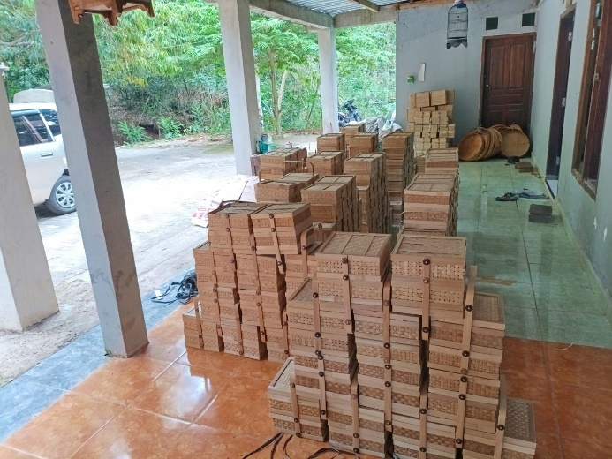
Figure 3. Location of the Bamboo Distro Business
(Research Documentation, 2026)
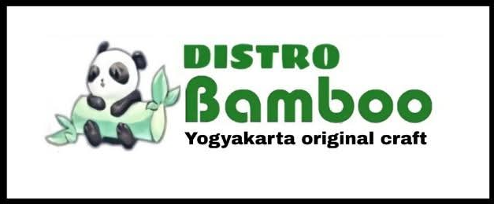
Figure 4. Bamboo Distro Business Logo
(Research Documentation, 2026)
In addition to its economic function, this business serves as a means of empowering the local Dlingo community by absorbing labor from farm laborers to productive bamboo craftsmen.
Research Results
Research Informant Profile
Table 6. Profile of Consent Informants

No. | Informant Name | Category | Age
1 | Ardhitya Furqon W | Owner | 32
2 | Rizki | Employee | 23
3 | Atun | Employee | 31
4 | Rohmah | Customer | 28
5 | Anton | Customer | 31
6 | Lastri | Customer | 52
Source: Research Results, 2026

Source: Research Results, 2026
Figure 5. Profile of Consent Informants
Reduction and Categorization of Interview Findings
The interview results were analyzed using thematic coding techniques, resulting in four main dimensions of CRM implementation, as presented in the following table:
Table 7. Categorization of CRM Implementation on the Bamboo Distro
CRM Dimension | Implementation Indicator | Empirical Findings | Impact on Loyalty
Customer Identification | Recognition of regular customers | Direct interaction and manual recording of repeat-order customers | Increased customer retention
Customer Differentiation | Needs-based segmentation | Product recommendations based on usage purpose (events/celebrations/household use) | Increased personalized satisfaction
Customer Interaction | Multi-channel communication | Integration of offline services with WhatsApp and Instagram | Word-of-mouth formation
Service Personalization | Complaint handling and order flexibility | Product replacement and custom orders | Strengthened trust relationship
Source: Research Results, 2026
Customer Loyalty Indicators
Table 8. Loyalty Indicators Based on Customer Perception
Loyalty Indicator | Informant Statement (Translated) | Thematic Interpretation
Repeat Purchase | "The product is durable and meets expectations." | Functional Satisfaction
Trust | "I already trust the quality." | Emotional Trust
Price Tolerance | "The price difference is not an issue." | Non-Economic Loyalty
Recommendation | "I often recommend it to family." | Advocacy Behavior
Switching Resistance | "I don't want to try other places." | Retention Commitment
Source: Research Results, 2026
Discussion
The research results show that CRM implementation at Distro Bamboo is relational and based on social interactions, not a formal digital system. Key findings indicate that:
- Local Product Quality
Handmade bamboo products provide authentic value (perceived authenticity) that increases customer trust in product quality.
- Empathetic Service
Communicative, friendly, and informative service has been shown to increase customer satisfaction during the purchasing decision-making process.
- Personalization Approach
Product recommendations tailored to customer needs create an individualized shopping experience (personalized service experience).
- Trust-Based Relationship
Customer loyalty is more influenced by emotional relationships and long-term trust than by price considerations.
Local Product Quality
Trust
Customer Satisfaction
Personalized Interactions
Empathic Service
Customer Loyalty
Repeat Purchase & Word of Mouth
Figure 6. Relational CRM Implementation Model for MSMEs
Theoretically, these findings confirm that CRM implementation in the craft-based MSME sector does not have to rely on high-tech systems, but can be achieved through a consistent social relationship approach (social bonding strategy).
Thus, the integration of local product quality, personalized service, and ongoing communication has been proven to:
- Increase customer satisfaction
- Strengthen trust
- Encourage repeat purchases
- Generate word-of-mouth promotion
This is an indicator of the success of a relationship-based CRM strategy in maintaining the sustainability of Distro Bamboo's business amidst price competition from modern plastic substitute products.

5. CONCLUSIONS AND RECOMMENDATIONS
5.1. Conclusion
This study concludes that the implementation of CRM at Distro Bamboo was carried out through an organic, personalized strategy, including interaction-based customer identification, responsive two-way communication, solution-oriented after-sales service, and value creation through quality products and flexible ordering. Consequently, this strategy successfully built trust and satisfaction, encouraging repeat purchases, creating customer advocacy (word of mouth), and building strong resistance to competitors' offerings. Distro Bamboo's customer loyalty is not built on low prices, but on a foundation of quality relationships and products. The main obstacle lies in the lack of a systematic customer data recording system, but this also presents an opportunity to develop a simple system to increase CRM effectiveness in the future.
5.2. Recommendations
For Distro Bamboo, it is recommended to begin documenting customer data in a simple way, for example through a digital notebook or spreadsheet, to support more planned service personalization. Product quality and warm service, which are already key strengths, must be maintained and passed on to all employees. Social media optimization also needs to be enhanced, not only as a product showcase but also as a channel for follow-up and value-added communication.
For future researchers, it is recommended to conduct quantitative studies to examine the influence of personal variables in CRM on customer loyalty in similar sectors. Comparative research across craft MSMEs in different regions could also be conducted to examine the influence of socio-cultural context on the effectiveness of CRM strategies.

REFERENCES
Badan Pusat Statistik Daerah Istimewa Yogyakarta. (2025). Statistics of micro, small, and medium enterprises (MSMEs) of the Special Region of Yogyakarta 2025. BPS Province of the Special Region of Yogyakarta.
Buttle, F., & Maklan, S. (2019). Customer relationship management: Concepts and technologies (4th ed.). Routledge.
Creswell, J. W., & Poth, C. N. (2021). Qualitative inquiry and research design: Choosing among five approaches (4th ed.). SAGE Publications.
Denzin, N. K., & Lincoln, Y. S. (2018). The SAGE handbook of qualitative research (5th ed.). SAGE Publications.
Dick, A. S., & Basu, K. (1994). Customer loyalty: Toward an integrated conceptual framework. Journal of the Academy of Marketing Science, 22(2), 99–113. https://doi.org/10.1177/0092070394222001
Forootani, E., et al. (2022). The mediating role of digital marketing in CRM and firm performance. Journal of Relationship Marketing, 21(4), 305–322.
Fortune Business Insights. (2024). Engineered wood market size, share & industry analysis, 2024–2032. https://www.fortunebusinessinsights.com/engineered-wood-market-103328
Grand View Research. (2023). Sustainable construction materials market size, share & trends analysis report, 2023–2030. https://www.grandviewresearch.com/industry-analysis/sustainable-construction-materials-market
Griffin, J. (2017). Customer loyalty: How to earn it, how to keep it. Jossey-Bass.
Keller, E., & Fay, B. (2019). The landmark study on word-of-mouth and its impact in the digital age. Keller Fay Group.
Kotler, P., & Keller, K. L. (2020). Marketing management (15th ed.). Pearson Education.
Kumar, V., & Reinartz, W. (2016). Creating enduring customer value. Journal of Marketing, 80(6), 36–68. https://doi.org/10.1509/jm.15.0414
Kvale, S. (2007). Doing interviews. SAGE Publications.
Lemon, K. N., & Verhoef, P. C. (2016). Understanding customer experience throughout the customer journey. Journal of Marketing, 80(6), 69–96. https://doi.org/10.1509/jm.15.0420
Lincoln, Y. S., & Guba, E. G. (1985). Naturalistic inquiry. SAGE Publications.
Miles, M. B., Huberman, A. M., & Saldaña, J. (2014). Qualitative data analysis: A methods sourcebook (3rd ed.). SAGE Publications.
Moleong, L. J. (2019). Qualitative research methodology (Revised ed.). PT Remaja Rosdakarya.
Noy, C. (2008). Sampling knowledge: The hermeneutics of snowball sampling. International Journal of Social Research Methodology, 11(4), 327–344. https://doi.org/10.1080/13645570701401305
Oliver, R. L. (2015). Satisfaction: A behavioral perspective on the consumer (2nd ed.). Routledge. https://doi.org/10.4324/9781315700892
Payne, A., & Frow, P. (2005). A strategic framework for customer relationship management. Journal of Marketing, 69(4), 167–176.
Payne, A., & Frow, P. (2017). Strategic customer management: Integrating relationship marketing and CRM. Cambridge University Press. https://doi.org/10.1017/9781316890936
Reichheld, F. F. (2003). The one number you need to grow. Harvard Business Review, 81(12), 46–54.
Rulinawaty, R., Risnashari, R., & Lince, R. (2021). “Orang kampung,” digital marketing, and public policy: A review and research agenda (Case study: Traditional marketing of Songko Recca). Selaparang: Jurnal Pengabdian Masyarakat Berkemajuan, 5(1), 575–584. https://doi.org/10.31764/jpmb.v5i1.6509
Silva, L., et al. (2022). Digital CRM applications and customer engagement in culinary SMEs. Small Business International Review, 6(2), 77–89.
Spradley, J. P. (2016). Participant observation. Waveland Press.

Customer Relationship Management (CRM) Implementation Strategy to Increase Customer Loyalty at Distro Bamboo
in Dlingo, Bantul Regency, Yogyakarta Special Region
Appendix I
Interview Documentation

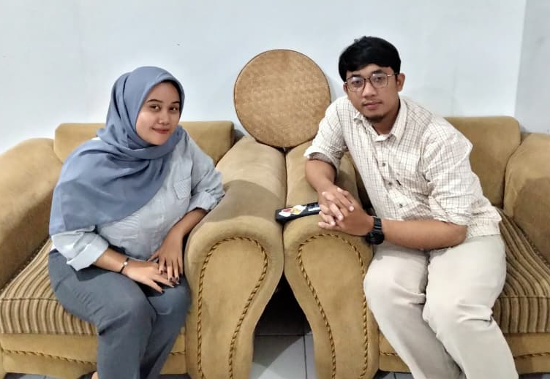
Interview with Furqon
Owner of Distro Bamboo
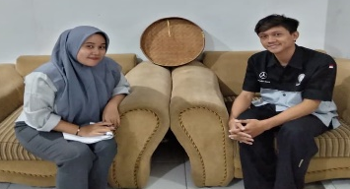
Interview with Rizki and Atun
Employees of Distro Bamboo

Interview with Anto
Customer of Distro Bamboo

Interview with Rohmah
Customer of Distro Bamboo
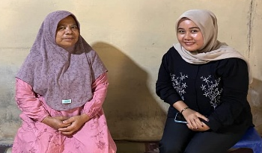
Interview with Lastri
Customer of Distro Bamboo

Customer Relationship Management (CRM) Implementation Strategy to Increase Customer Loyalty at Distro Bamboo
in Dlingo, Bantul Regency, Yogyakarta Special Region
Appendix II
Distro Bamboo Product Photos

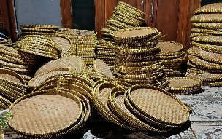
Figure 1. Distro Bamboo Products
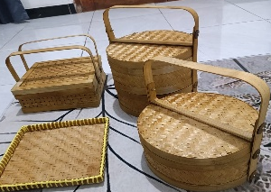
Figure 2. Distro Bamboo Products
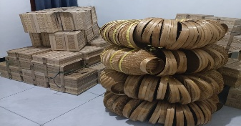
Figure 3. Distro Bamboo Products
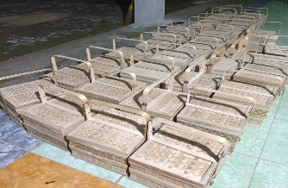
Figure 4. Distro Bamboo Products

