Entrepreneurial Potentials of Tourism Villages in Bantul Regency, Yogyakarta

Ajie Wicaksono
Sekolah Tinggi Pariwisata Ambarrukmo (STIPRAM), Yogyakarta
Email: ajiewicaksono@stipram.ac.id

ABSTRACT
Tourism villages in Yogyakarta, Indonesia, promote economic diversification, cultural preservation, and community empowerment. However, research lacks connection between heritage and innovative business strategies, affecting livelihoods. This research aims to explore the connection between cultural heritage and innovative business strategies in tourism villages in Yogyakarta, Indonesia, focusing on sustainable livelihoods and entrepreneurial ecosystems. The study employed VOSviewer analysis and a systematic literature review to explore entrepreneurial potential in tourism villages in Bantul Regency, utilizing Scopus and Google Scholar databases by using Publish or Perish application. 41 research articles were derived after conducting PRISMA analysis with some inclusion and exclusion criteria. The results show that the network visualization shows a central hub of medium to large-sized nodes, including "village," "tourism," and "Bantul Regency." Five clusters are identified, with gaps in cross-cluster integration, government-economic nexus, and capacity building metrics. The study emphasizes the need for quantitative metrics on capacity-building effects and interdisciplinary integration between cultural studies, business innovation research, and public policy analysis. It also calls for methodological advancement in measurement instruments and evaluation frameworks for rural tourism entrepreneurship.
Keywords: entrepreneurial potentials, tourism villages, Bantul regency, Yogyakarta.

- INTRODUCTION
Tourism villages offer opportunities for economic diversification, cultural preservation, and community empowerment as a critical component of integrated development. Although the entrepreneurial opportunities in the Bantul Regency of Yogyakarta have yet to be fully explored, the region is home to a burgeoning tourism sector that is founded on a plethora of natural and cultural resources (Utami et al., 2023). Studies have previously documented the significance of village leadership (Akmala Hadita & Rashid, 2025), civil society (Pambudi et al., 2022; Widiartanto et al., 2022), participatory development (Thetsane, 2019), and business model innovation in rural tourism entrepreneurship (Utami et al., 2023). However, there is a lack of research that establishes a connection between cultural heritage and innovative business strategies and evaluates the effects of governance systems on the livelihoods of households.
By integrating local culture, natural resources, and community participation, tourism villages in Indonesia serve as a critical focal point for rural development, advancing economic and socio-cultural development. The 'Desa Wisata' concept is promoted by the Ministry of Tourism as a method of promoting sustainable self-employment and improving the well-being of the local populace (Halim & Ervina, 2021). The impact of entrepreneurship in the context of tourism villages is illustrated by the unique case of Bantul Regency in Yogyakarta Province (Kusmantini et al., 2025; I. Rahman & Hakim, 2024). However, there is a discrepancy in the comprehension of the enablers and barriers to entrepreneurial opportunities in these villages. There is a tendency in the existing literature to focus on specific cases or general tourism development indicators, without an interdisciplinary coherent synthesis (Rahmadi & Nugroho, 2022; Wijayanti & Dewi, 2016).
Previous research has identified numerous issues, including the absence of bibliometric mapping in tourism-entrepreneurship research (Chhabra et al., 2025; García-Lillo et al., 2023), a mosaic of synthesized cases (Baiocco et al., 2023; Manalu et al., 2024; Solvoll et al., 2015), standalone case study fragments (Ochoa Jiménez et al., 2022; Saufi et al., 2023; Torkington et al., 2025), a restricted Bantul-centric focus (Aquino & Boluk, 2025), and the implementation of integrated SLR and VOSviewer (Pambudi et al., 2022; Ridanpää, 2025; Teruel-Sanchez et al., 2025). In Bantul, there are individual case study reports of village entrepreneurship; however, these previous studies are not compiled and integrated to form a comprehensive analysis of the entrepreneurial drivers across various contexts and villages. Bantul Regency is the subject of a smaller number of studies on tourism-based entrepreneurship, although there are more comprehensive studies. A study on the growth of tourism villages in Bantul identified the primary constraining factors as a lack of support and participation from community stakeholders, gaps in infrastructure, and human resource challenges. Community-based tourism in Indonesia has been the subject of a bibliometric study (García-Lillo et al., 2023; Ochoa Jiménez et al., 2022); however, there has been no investigation into the intersection of tourism villages and entrepreneurship in Bantul Regency.
It is impossible to identify the authors, institutions, and dominant thematic threads of the region in the absence of such mapping, which subsequently impedes the identification of potential research frontiers and collaboration pathways (Baiocco et al., 2023; Chhabra et al., 2025; Dias et al., 2023). This investigation is anticipated to generate dual-impact results, which would include substantial contributions to scholarly discourse and practical strategies for the entrepreneurial development of tourism villages in the Bantul region. The research purposes to provide policymakers, village institutions, and private-sector stakeholders with practical recommendations to develop customized strategies that promote sustainable livelihoods and entrepreneurial ecosystems, as well as evidence-based interventions, by concentrating on these gap areas. By addressing these specific gaps, the research seeks to empower local stakeholders with actionable insights that can enhance economic opportunities and foster sustainable practices within tourism villages. Ultimately, this approach aims to create a more resilient and thriving community in the Bantul region. However, some critics contend that a universal strategy might ignore the distinct cultural and social dynamics of each village, potentially resulting in ineffective solutions.
Additionally, there is concern that focusing solely on economic growth could overshadow the importance of preserving local traditions and environmental integrity (Nurozi, 2021; Poniasih et al., 2022). These results highlight the importance of tailoring strategies to fit the specific needs and characteristics of each village, ensuring that development does not compromise cultural heritage or environmental sustainability. Balancing economic growth with these values is essential for creating long-term benefits for the community (A. Rahman & Natalia, 2025; Wardani et al., 2023). Achieving a harmonious coexistence between economic growth and the preservation of cultural heritage is not only a noble goal but also a necessary endeavor for sustainable development. When local traditions and environmental integrity risk being overshadowed, it becomes imperative to tailor strategies that resonate with the unique needs of each village (Fajri, 2020; Ramadhani et al., 2021; Suharti et al., 2023). By prioritizing development initiatives that respect and enhance cultural identities while safeguarding the environment, communities can create a foundation for prosperity that honors their heritage. Ultimately, striking this balance ensures that economic advancement does not come at the expense of community values, paving the way for long-term benefits that enrich both current and future generations.
The dominant themes and developing trends of tourism villages with entrepreneurial studies are not identified through bibliometric mapping. This research addresses the gap by conducting a systematic literature review (SLR) and bibliometric analysis using VOSviewer to identify the critical success factors and entrepreneurial competencies of the Bantul tourism villages, illustrate the evolution of scholarly debates on entrepreneurship in tourism, and provide direct, concrete recommendations to policymakers, community and local leaders, and field practitioners to enhance the entrepreneurial climate in Bantul Regency and rural areas of the region. This study employs a two-pronged approach—VOSviewer network visualization and a systematic literature review (SLR)—to map the intellectual landscape and synthesize key findings related to the entrepreneurial potential of tourism villages within Bantul Regency.
By analyzing 41 articles drawn from the Scopus and Google Scholar databases, this research identifies thematic clusters, uncovers knowledge gaps, and traces temporal trends from 2015 to 2025. The following research questions of this research are:
- What are the dominant thematic clusters and intellectual structures underpinning research on the entrepreneurial potential of tourism villages in Bantul Regency, as revealed by VOSviewer overlay and density visualizations?
- How have research themes evolved over time—from initial economic impact studies during 2015 to 2025 to emerging focuses on innovation and governance?
- What gaps exist between cultural heritage preservation and business innovation, and between governance frameworks and livelihood outcomes, within the context of tourism village entrepreneurship?
- Which strategies and metrics have been proposed to enhance capacity building, institutional support, and sustainable enterprise development in Bantul’s tourism villages?

- METHODOLOGY
A systematic literature review (SLR) method was implemented throughout this investigation. For this reason, this method necessitates conducting an exhaustive examination of pertinent literature that pertains to the specific subjects being examined. The primary objective of this research was to investigate the strategies employed in specific fields of study within the broader scope of this analysis. Because of Scopus's international reputation and Google Scholar's established reputation, the researchers selected to use themselves as reference resources. There were three distinct categories for organizing the process of searching for research articles via Publish or Perish application. There were three categories: the entrepreneurial potential of tourism villages on the Scopus database, the entrepreneurial potential of tourism villages on Google Scholar, and the entrepreneurial potential of tourism villages in Bantul Regency on Google Scholar. In order to conduct a scientific analysis, the PRISMA analysis was employed to examine the complete text articles obtained from the Scopus and Google Scholar databases.
Criteria for Inclusion and Exclusion
In this research, the VOSviewer analysis and the Systematic Literature Teview (SLR) investigation employed a five-stage process to identify pertinent literature. First, the selected publication data was included to full-text articles and excluded book reviews, theses, dissertations, book chapters, or proceedings or the like. Second, the full-text articles were restricted to those that were published within the past decade (2015–2025) and concentrate on the entrepreneurial potential of tourism villages on the Scopus database, the entrepreneurial potential of tourism villages in the Google Scholar database, and the entrepreneurial potential of tourism villages in Bantul Regency in the Google Scholar database. Third, the researchers exclusively employed the Scopus and Google Scholar databases. Fourth, the researchers utilized Zotero reference management to manage citations and facilitated the search for full-text articles using Publish or Perish 8. Fifth, the researchers prioritized full-text articles that were accessible via open access.
Eligibility Screening and Assessment
In the process of systematic planning used Publish and Perish 8 with the 3 categories of entrepreneurial potential of tourism villages on the Scopus database, entrepreneurial potential of tourism villages on Google Scholar, and entrepreneurial potential of tourism villages in Bantul Regency on Google Scholar. Table 1 presents the results during 2015 to 2025.
Table 1. The results during 2015 and 2025
No | Category | Database | Number
 | entrepreneurial potential of tourism villages | Scopus | 78
 | entrepreneurial potential of tourism villages | Google Scholar | 103
 | entrepreneurial potential of tourism villages in Bantul Regency | Google Scholar | 87
Total |  |  | 268

Following the mentioned criteria, the researchers conducted an analysis and gathered a total of 268 research articles. These articles were initially stored in a folder within the Zotero Reference Manager. Subsequently, they were converted to 'RIS' formats and subsequently selected by PRISMA analysis using inclusion and exclusion criteria for VOSviewer analysis and SLR investigation.
PRISMA Analysis
The method of looking for scientific articles was divided down into a number of distinct areas. In the process of systematic planning used Publish and Perish 8 with the 3 categories of entrepreneurial potential of tourism villages on the Scopus database, entrepreneurial potential of tourism villages on Google Scholar, and entrepreneurial potential of tourism villages in Bantul Regency on Google Scholar. According to the data shown in Figure 1, the PRISMA analysis is summarized as follows.
Identification
Comprehensive data acquired from the Scopus and Google Scholar databases utilizing Publish and Perish 8. (n=268)
Identified results which are the research articles. (n=160)
The data which are not research articles. (n=108)
The filtered articles. (n=97)
The reduced articles are due to a lack of alignment with the categories. (n=63)
Filtering
The eligible articles. (n=44)
The included articles. (n=41)
Eligibility
Included

The eliminated articles due to their lack of relevance to the current research. (n=53)

The diminished articles due to no available open access. (n=3)

Figure 2. PRISMA analysis chart flow
According to Figure 2, the PRISMA analysis findings were imported from the Scopus and the Google Scholar databases. By using the categories of entrepreneurial potential of tourism villages on the Scopus database, entrepreneurial potential of tourism villages on Google Scholar, and entrepreneurial potential of tourism villages in Bantul Regency on Google Scholar, a search was conducted for the research articles published between 2015 and 2025 (10 years). The search yielded a total of 628 publications, as determined by the Publish and Perish 8 tool. However, the researchers identified 108 articles that were not categorized as research articles. The identified results come up with 160 research articles. After reducing 63 due to a lack of alignment with the categories, the articles were left with 97 ones. 53 articles were eliminated due to lack of relevance to the current research, resulting in a total of 44 eligible articles. Furthermore, 3 articles were diminished due to no available open access. The included research articles with the complete comprehensive study findings were in the final phase. The researchers acquired 41 articles with the significant values from the Scopus and the Google Scholar databases. Furthermore, those 41 research articles were converted into the RIS format from Zotero Reference Manager to be loaded in VOSviewer application.

3. RESULTS AND DISCUSSION
This research come up with the VOSviewer analysis and the Systematic Literature Review. Based on the included articles by PRISMA analysis, the researchers performed an analysis and gathered a total of 41 research articles with 3 categories of entrepreneurial potential of tourism villages on the Scopus database, entrepreneurial potential of tourism villages on Google Scholar, and entrepreneurial potential of tourism villages in Bantul Regency on Google Scholar.
VOSviewer Analysis
These included articles were imported into “RIS” format to be loaded in the VOSviewer application to visualize the network, the overlay, and the density. Figure 2 illustrates the results in a network visualization.
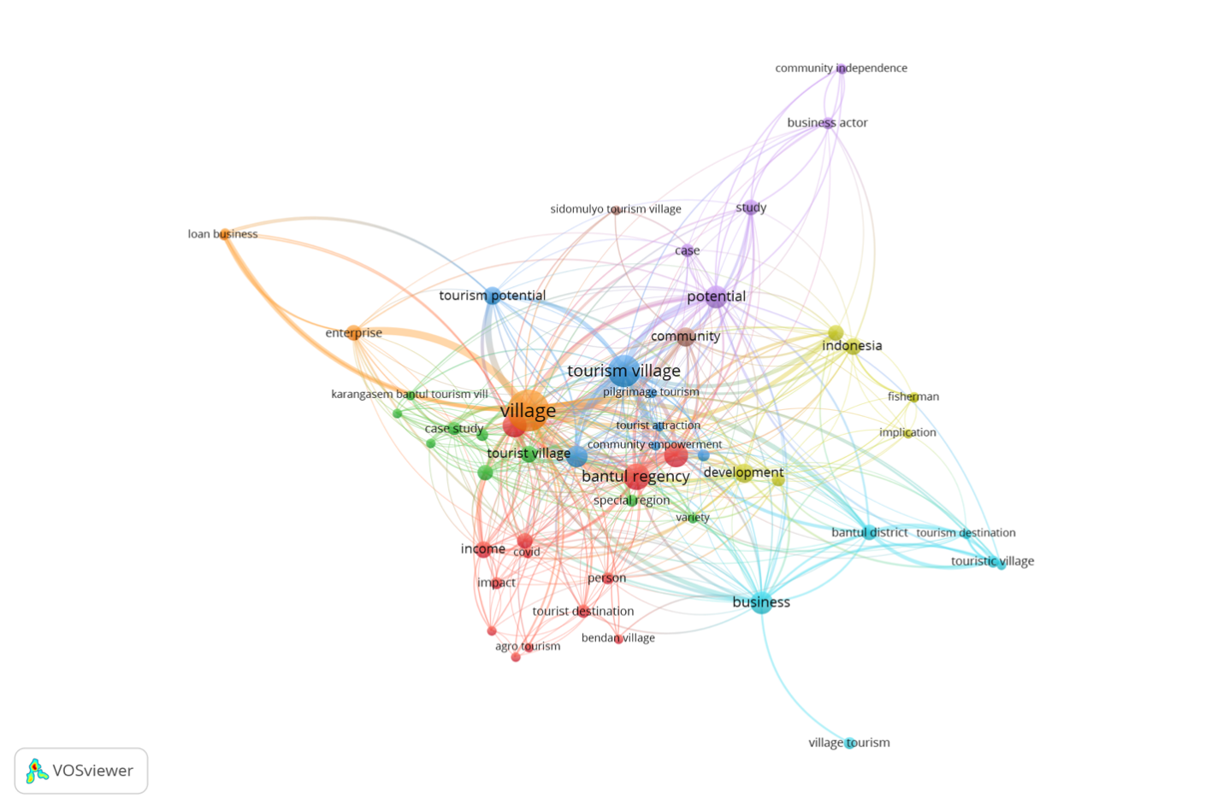
Figure 2. The results in a network visualization form by VOSviewer
VOSviewer's network visualization focuses on the research regarding the entrepreneurial potential of the tourism villages situated in Bantul Regency, Yogyakarta. A core is present in the network structure, which is composed of a dense network of medium to large-sized nodes, including "village," "tourism," and "Bantul Regency," which acts as central hubs. This core is encircled by a semi-peripheral layer of moderately connected nodes, including "community," "business," and "entrepreneurship." These nodes function as transitional bridges to more specialized niche areas and core concepts. Five distinct clusters are identified by their respective colors: the Green Cluster, which represents community and development, the Red Cluster, which represents economic impact, the Blue Cluster, which represents business models and innovation, the Yellow Cluster, which represents governance and policy, and the Purple Cluster, which represents cultural and heritage tourism. Cross-cluster integration, government-economic nexus, and capacity building metrics are among the numerous gaps identified for future research, as indicated by the outlined topology. The cultural heritage cluster and the business innovation cluster are relatively weakly connected, which suggests that there are gaps in the development of novel entrepreneurial models that are rooted in tradition. The necessity of concentrating on the impact of institutional frameworks on household level economics is suggested by the sparse direct connections between policy nodes and those who are concerned with the impacts on livelihoods. Furthermore, Figure 3 illustrates the results in a density visualization.
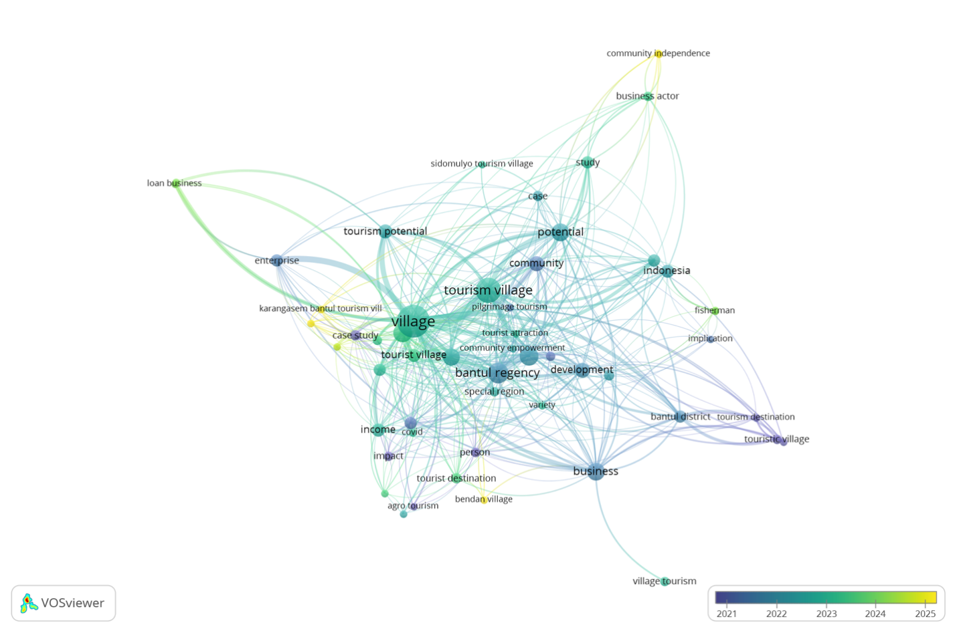
Figure 3. The results in an overlay visualization form by VOSviewer
The VOSviewer overlay visualization tools track the evolution of research themes concerning the entrepreneurial potentials of tourism villages in Bantul Regency from 2021 to 2025. The use of terms such as "village," "tourism," and "Bantul Region" is indicated by the use of greencolors, which indicates that they have been employed throughout the entire period. In deeper blues, earlier themes such as "income," "livelihood," and "tourist destination" are depicted. The result implies that the economic impact and characterization of the destination were the primary focus of the earliest studies conducted from 2021 to 2024.
The socio-developmental aspects of village tourism and community empowerment are the primary focus of research from 2022 to 2023, as evidenced by the mid-level green coloration of intermediate themes such as "community," "capacity building," and "development." From 2024 to 2025, the subsequent themes of "digitalization," "innovation," and "sustainability" emerged, as indicated by the yellow color. The economic cluster, which was initially dominant, has since cooled to a green color, indicating that the focus of discussions on economic viability has shifted to a broader developmental discourse. The community-oriented cluster transitions from green to light-yellow, demonstrating the more recent integration of participatory approaches and governance. From the most recent preprint on the innovation and sustainability cluster, which encompasses digitalization, sustainable entrepreneurship, and value chain optimization, the most contemporary research front (2024-2025) has emerged. Understanding these temporal clusters can help scholars and policymakers align their future investigations with evolving priorities, such as ensuring that tourism intervention measures in Bantul's villages address both stale and emerging concerns. Furthermore, Figure 4 illustrates the results in a density visualization.
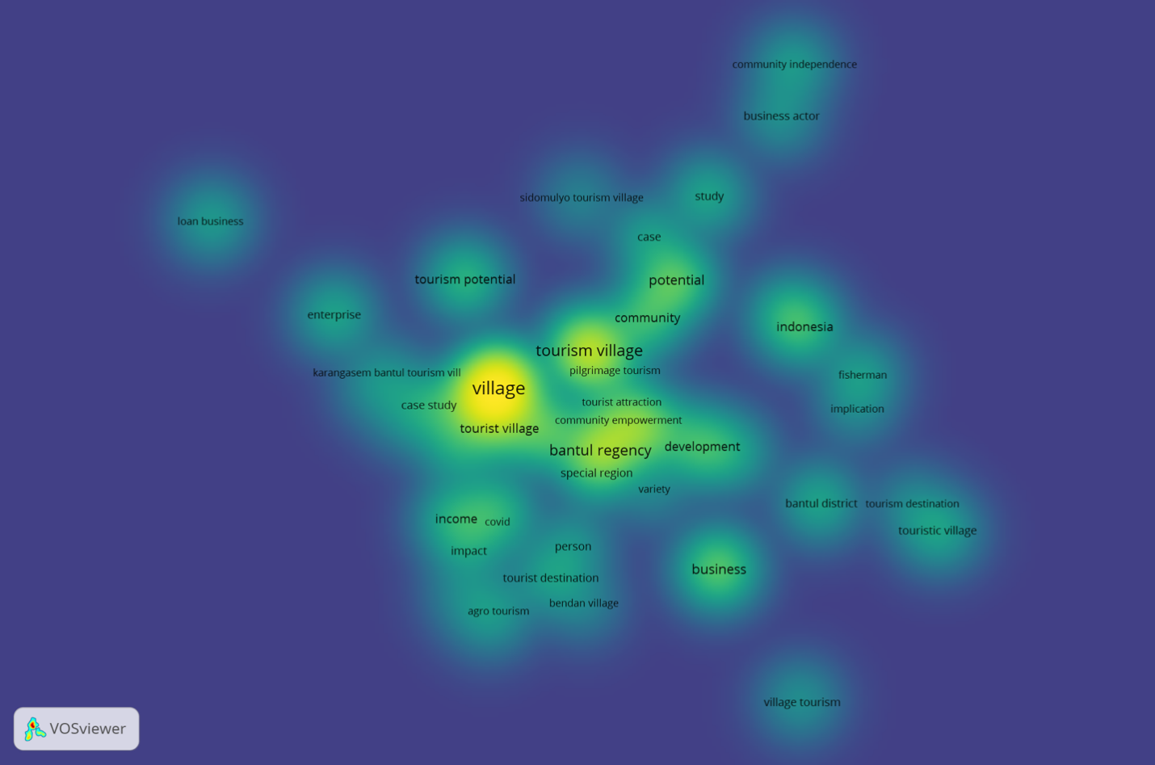
Figure 3. The results in a density visualization form by VOSviewer
The VOSviewer density visualization is a tool that uses a heat map approach to analyze the entrepreneurial potentials of tourism villages in Bantul Regency, Yogyakarta. It transforms the network structure into a continuous density surface, with colors representing the local concentration of research terms and their interconnected relationships. The visualization reveals a central high-density core, centered around foundational terms like "village," "tourism," and "Bantul Regency." Intermediate density zones, encompassing terms like "community," "development," "entrepreneurship," and "Indonesia," appear in green. Peripheral low-density areas, containing terms with lower co-occurrence frequencies or more specialized applications, display blue coloration. Conceptual saturation analysis reveals areas of research saturation (high-density yellow regions) versus underexplored territories (blue peripheral zones). Thematic centrality assessment confirms that village tourism entrepreneurship concepts occupy the intellectual center of this research domain, with a gradual decline toward the periphery indicating decreasing conceptual integration as topics become more specialized.
Systematic Literature Review
The systematic literature review (SLR) aimed to explore the entrepreneurial potential of tourism villages in Bantul Regency, Yogyakarta, over a ten-year period (2015-2025). The review used Scopus and Google Scholar databases to synthesize findings from 628 publications. The 41 selected articles were exported in RIS format and imported into VOSviewer for network, overlay, and density visualizations. Thematic clustering and network findings identified core concepts such as village, tourism, and Bantul Regency. Knowledge gaps were identified, such as weak links between cultural heritage and business innovation, sparse connections between governance frameworks and livelihood outcomes, and the need for quantitative metrics on capacity-building effects. Temporal trends were identified, such as early focus on economic impact (2021-2022), mid-period shifts (2022-2023), emerging themes (2024-2025), and conceptual concentration (2024-2025). Table 2 presents the description of Systematic Literature Review of this research on the entrepreneurial potentials of tourism villages in Bantul Regency, Yogyakarta.
Table 1. Systematic Literature Review of this research on the entrepreneurial potentials of tourism villages in Bantul Regency, Yogyakarta
No | Key Takeaways | Points
1. | Knowledge Gaps | - Weak links between cultural heritage and business innovation  - Sparse connections between governance frameworks and livelihood outcomes  - The need for quantitative metrics on capacity-building effects
2 | Temporal trends | - Early focus on economic impact (2021-2022)  - Mid-period shifts (2022-2023)  - Emerging themes (2024-2025)  - Conceptual concentration (2024-2025)
According to Table 2, this systematic literature review on tourism village entrepreneurship in Bantul Regency, Yogyakarta, identifies three critical knowledge gaps: Cultural Heritage-Business Innovation Disconnect, Governance-Livelihood Impact Separation, and Capacity-Building Measurement Deficit. The review also outlines four distinct evolutionary phases in the research domain: Early Economic Focus (2021-2022), Mid-Period Paradigm Shifts (2022-2023), Emerging Thematic Frontiers (2024-2025), and Conceptual Consolidation (2024-2025). The progression from economic focus to conceptual concentration demonstrates the disciplinary maturation of tourism village entrepreneurship research, evolving from descriptive economic analyses to sophisticated theoretical frameworks. Interdisciplinary integration needs are identified, particularly between cultural studies, business innovation research, and public policy analysis. The emphasis on quantitative metrics suggests the need for methodological advancement in measurement instruments and evaluation frameworks specific to rural tourism entrepreneurship contexts. This categorization provides a strategic roadmap for future research directions and highlights the achievements and limitations of current scholarly understanding in the field.

DISCUSSION
The review of tourism-village entrepreneurship in Bantul Regency, Yogyakarta, indicates that there has been a mature and diverse body of research over the past decade. However, some critics argue that, despite the apparent maturity of the research, there is still a lack of practical applications that can effectively support local entrepreneurs. Additionally, the diversity of studies may not necessarily translate into actionable strategies for improving tourism and economic development in the region. Earlier research has focused on the socio-economic implications of tourism in rural areas, specifically in relation to income and livelihood opportunities. Nevertheless, the scholarship underwent a transformation in 2022-2023, with a particular emphasis on the sustainability of entrepreneurial development, equity in social power structures, and community development and empowerment. In the most recent phase (2024-2025), there is a clear emphasis on sustainability, innovation, and digitalization, which indicates a transition from descriptive research to a prescriptive and normative approach.
Based on VOSviewer's network analysis, the five primary thematic clusters are as follows: community and development; economic impact; business models and innovations; governance and policy; and cultural and heritage tourism. These clusters demonstrate the field's interdisciplinary breadth; however, the tenuous connections among certain clusters indicate areas where collaborative work from various disciplines could be further developed. While the thematic clusters identified by VOSviewer highlight significant areas of focus, some critics argue that the overlapping nature of these themes can lead to confusion and dilution of specific research agendas. Additionally, the emphasis on interdisciplinary collaboration might overshadow the value of specialized study within each distinct cluster, which can yield deeper insights into particular aspects of the field. The integration of culture, business model, and policy studies would provide a more comprehensive analysis of how villages utilize intangible heritage assets to create remarkable entrepreneurial models within favorable policy frameworks.
The bar chart below visually summarizes the evolution of major research themes in the study of tourism-village entrepreneurship in Bantul Regency, as discussed in the report. It highlights how academic focus shifted across three distinct periods illustrated in Figure 4.
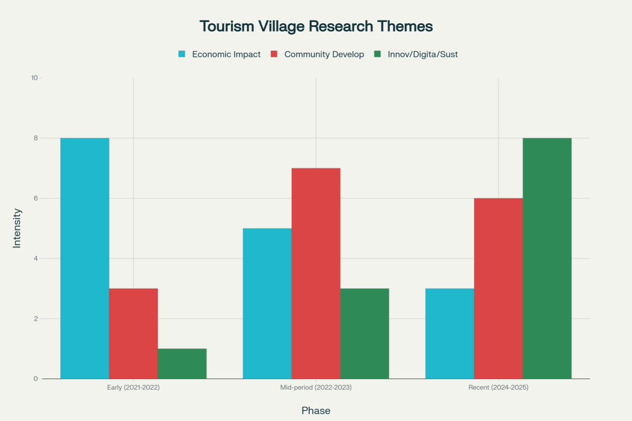
Figure 4. Research themes evolution in tourism-village entrepreneurship in Bantul Regency by phase (Early, Mid-period, Recent)
The study of tourism-village entrepreneurship in Bantul Regency has evolved over three distinct periods. The first phase focused on economic impact, focusing on income and livelihood outcomes. The second phase shifted towards community development, emphasizing empowerment, social capital, and participatory governance. The third phase saw the rise of innovation, digitalization, and sustainability, reflecting the field's shift towards long-term viability, technology adoption, and innovative entrepreneurial approaches. This visual representation illustrates the transition from foundational economic analyses to more nuanced, future-oriented research, aligning with the findings from a systematic review and network analysis. Furthermore, Figure 5 illustrates the conceptual map.
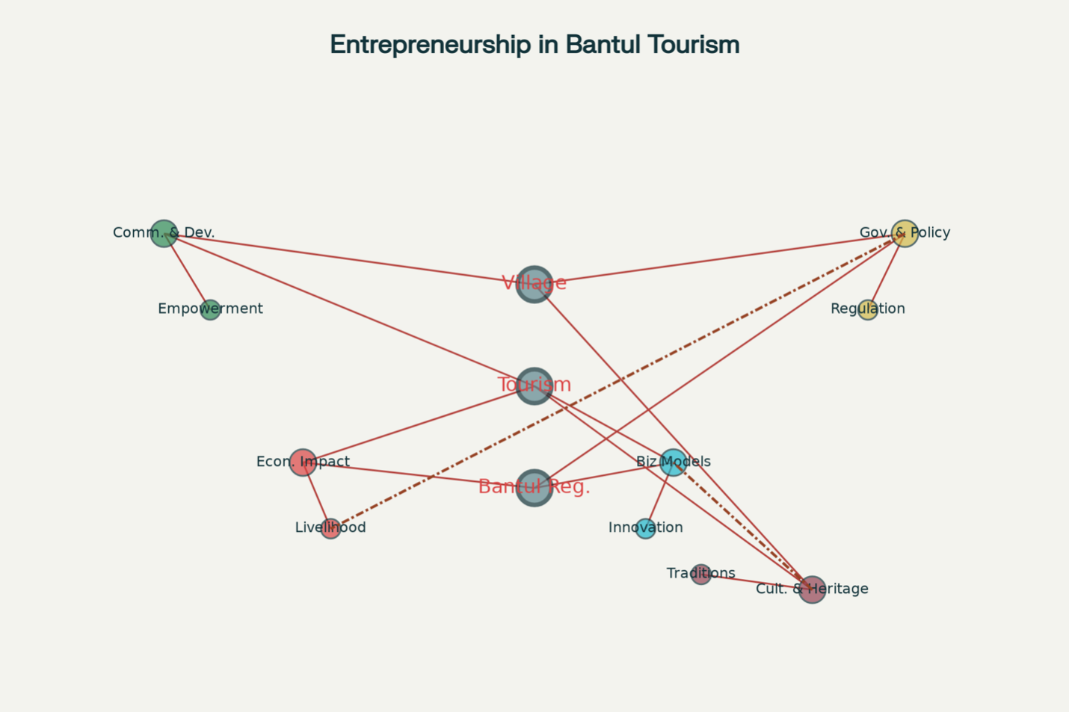
Figure 5. Conceptual Map of Entrepreneurial Potentials of Tourism Villages Research in Bantul Regency
According to Figure 5, the conceptual map illustrates the research landscape for the analysis of entrepreneurial potentials in tourism villages in Bantul Regency, Yogyakarta. The map consists of five thematic clusters: Community & Development (Green), Economic Impact (Red), Business Models & Innovation (Blue), Government & Policy (Yellow), and Cultural & Heritage Tourism (Purple). The high-density core clusters "village," "tourism," and "Bantul Regency" represent the most frequently studied concepts. The map also highlights knowledge gaps (dashed lines) between "Cultural & Heritage Tourism" and "Business Models & Innovation" and "Governance & Policy" and outcomes in "Economic Impact" (specifically livelihoods). These lines highlight areas where the literature indicates the need for further research integration. The map provides a clear understanding of the intellectual landscape of the research field.
The comprehension of the tenuous connection between business innovation and cultural heritage implies that academics have not fully conceptualized or measured the implementation of innovative value-creation strategies in tradition-based tourism ventures. However, some argue that the integration of innovative practices within tradition-based tourism can enhance cultural heritage rather than diminish it. By blending modern business strategies with traditional elements, these ventures can attract a wider audience while preserving and promoting their unique cultural narratives. The absence of standardized quantitative metrics for evaluating the construction of evaluative frameworks for capacity-building in policy analysis impedes the ability to compare programs and inform policy in a systematic manner, while sparse connections between policy frameworks and governance structures are indicative of a critical gap. Provided that the methodology undergoes sufficient innovation, such as the development of culturally appropriate instruments for evaluation, frameworks for impact evaluation, and mixed-method approaches, all of these gaps can be resolved.
- CONCLUSIONS
The study examines the entrepreneurial potential of tourism villages in Bantul Regency, Yogyakarta, using a VOSviewer analysis and a systematic literature review. It reveals that these villages are crucial for rural economic and socio-cultural development, leveraging local culture, natural resources, and community participation. The study identified five major thematic clusters: Community and Development, Economic Impact, Business Models and Innovation, Governance and Policy, and Cultural and Heritage Tourism. However, it identified knowledge gaps, particularly weak linkages between cultural heritage and business innovation, governance frameworks and livelihood outcomes, and a lack of quantitative metrics for capacity-building efforts. The research calls for evidence-based, context-specific strategies to foster sustainable entrepreneurship, tailored to the unique cultural and social dynamics of each village. It recommends strengthening collaboration across thematic domains and integrating cultural assets with innovative business models and governance frameworks.

REFERENCES
Akmala Hadita, & Rashid, S. (2025). Strengthening society participation on planning the development of a religious tourism village through transparency, accountability, communication and leadership. Journal of Nonformal Education, 10(2), 239–250. https://doi.org/10.15294/jone.v10i2.3209
Aquino, R. S., & Boluk, K. A. (2025). Social entrepreneurship in tourism: A framework-based scoping review and research agenda. Tourism Management Perspectives, 57, 101351. https://doi.org/10.1016/j.tmp.2025.101351
Baiocco, S., Leoni, L., & Paniccia, P. M. A. (2023). Entrepreneurship for sustainable development: Co-evolutionary evidence from the tourism sector. Journal of Small Business and Enterprise Development, 30(7), 1521–1546. https://doi.org/10.1108/JSBED-01-2023-0003
Chhabra, M., Luu, T. T., & Gupta, Y. (2025). Mapping the current and future issues of tourism entrepreneurship research: A systematic review of key themes and research gaps. Current Issues in Tourism, 1–21. https://doi.org/10.1080/13683500.2025.2507108
Dewi, R., & Yutsi, S. (2024). Community Empowerment in Tourism Management at Kampung Flory, Tridadi Village, Sleman Regency, Yogyakarta. Media Wisata, Query date: 2025-08-06 11:32:08. https://jurnal.ampta.ac.id/index.php/MWS/article/view/675
Dias, Á., González-Rodríguez, M. R., & Hallak, R. (2023). Nascent entrepreneurship: A critical perspective and research agenda in tourism and hospitality. International Journal of Contemporary Hospitality Management, 35(7), 2527–2544. https://doi.org/10.1108/IJCHM-07-2022-0853
Fajri, D. (2020). The development of Krebet tourism village in the Industry 4.0 era. Jurnal Pariwisata Terapan, Query date: 2025-08-06 11:32:08. https://journal.ugm.ac.id/jpt/article/view/55686
García-Lillo, F., Seva-Larrosa, P., & Sánchez-García, E. (2023). What is going on in entrepreneurship research? A bibliometric and SNA analysis. Journal of Business Research, 158, 113624. https://doi.org/10.1016/j.jbusres.2022.113624
Halim, D. K., & Ervina, E. (2021). Comparative study: Perception on sustainable tourism of urban and rural eco-villages in Bali. IOP Conference Series: Earth and Environmental Science, 704(1), 012036. https://doi.org/10.1088/1755-1315/704/1/012036
Kusmantini, T., Sutiono, H. T., Hartati, A. S., Robani, A., Diantoro, A. K., & Rahmadati, A. M. (2025). How do social entrepreneurship factors influence sustainable business development? The mediating role of social network. Asian Management and Business Review, 128–142. https://doi.org/10.20885/AMBR.vol5.iss1.art9
Manalu, S. A., Simatupang, T. M., & Novani, S. (2024). Tourism entrepreneurship research: A mixed embeddedness approach. Cogent Business & Management, 11(1), 2418421. https://doi.org/10.1080/23311975.2024.2418421
Nurozi, A. (2021). Design and potential of Halal tourism industry in Yogyakarta Special Region. Journal of Islamic Economics Lariba, Query date: 2025-08-06 11:32:08. https://journal.uii.ac.id/JIELariba/article/view/21861
Ochoa Jiménez, S., García García, A. R., Valdez Del Río, S., & Jacobo Hernández, C. A. (2022). Entrepreneurship in tourism studies in the 21st century: A bibliometric study of WoS and Scopus. Sage Open, 12(2), 21582440221102438. https://doi.org/10.1177/21582440221102438
Pambudi, S. S. I., Hakim, M. L., & Lesmana, V. Y. (2022). Network governance towards development policy of Podokoyo tourism village in Pasuruan regency. Jurnal Perencanaan Pembangunan: The Indonesian Journal of Development Planning, 6(2), 236–248. https://doi.org/10.36574/jpp.v6i2.339
Poniasih, N., Rosalia, F., Muklis, M., & Maryanah, T. (2022). Through village-owned business agencies, towards tough tourism village. Cepalo, Query date: 2025-08-06 11:32:08. https://jurnal.fh.unila.ac.id/index.php/cepalo/article/view/2582
Rahmadi, H., & Nugroho, S. P. (2022). Study of tourism travel patterns In Bantul Regency, Yogyakarta post pandemic COVID-19. Technium Social Sciences Journal, 28, 607–620. https://doi.org/10.47577/tssj.v28i1.5876
Rahman, A., & Natalia, D. (2025). Community independence as empowerment in tourism village development: A study from Batu City, East Java. Jurnal Pariwisata Pesona, Query date: 2025-08-06 11:32:08. https://jurnal.unmer.ac.id/index.php/jpp/article/view/1-12
Rahman, I., & Hakim, L. M. (2024). Development of creative economy based on local wisdom in the era of digital transformation through inclusive education and village community empowerment in Bantul Regency, Yogyakarta. BASKARA : Journal of Business and Entrepreneurship, 6(2), 213–224. https://doi.org/10.54268/baskara.v6i2.21629
Ramadhani, R., Suswanta, S., & ... (2021). E-Marketing of village tourism development strategy (Case study in the tourist village puncak sosok). Journal of Robotics and …, Query date: 2025-08-06 11:32:08. https://journal.umy.ac.id/index.php/jrc/article/view/8357
Ridanpää, R. (2025). Framework for regenerative entrepreneurship in tourism: Fostering reciprocal relationships within place. Tourism Geographies, 1–18. https://doi.org/10.1080/14616688.2025.2535690
Saufi, A., Genadi, Y., Agusdin, A., & Scott, N. (2023). The small tourism enterprise operators’ networking in dealing with the changing business environment. International Journal of Social Science and Business, 7(2), 483–493. https://doi.org/10.23887/ijssb.v7i2.60161
Solvoll, S., Alsos, G. A., & Bulanova, O. (2015). Tourism entrepreneurship – Review and future directions. Scandinavian Journal of Hospitality and Tourism, 15(sup1), 120–137. https://doi.org/10.1080/15022250.2015.1065592
Suharti, L., Sirine, H., & Martono, S. (2023). Developing a sustainable tourism village model: An exploratory study. Jurnal Manajemen …, Query date: 2025-08-06 11:32:08. https://jurnalmanajemen.petra.ac.id/index.php/man/article/view/25754
Teruel-Sanchez, R., Briones-Peñalver, A. J., Bernal-Conesa, J. A., & De Nieves-Nieto, C. (2025). Values of the entrepreneur as a driver of sustainable tourism entrepreneurship. Journal of International Entrepreneurship. https://doi.org/10.1007/s10843-025-00381-0
Thetsane, R. M. (2019). Local community participation in tourism development: The case of Katse villages in Lesotho. ATHENS JOURNAL OF TOURISM, 6(2), 123–140. https://doi.org/10.30958/ajt.6-2-4
Torkington, K., Eimermann, M., Ribeiro, F. P., & Conceição, S. (2025). Challenges for tourism-related lifestyle migrant entrepreneurship in rural areas of the Algarve, Portugal. Journal of Rural Studies, 115, 103562. https://doi.org/10.1016/j.jrurstud.2025.103562
Utami, D. D., Dhewanto, W., & Lestari, Y. D. (2023). Rural tourism entrepreneurship success factors for sustainable tourism village: Evidence from Indonesia. Cogent Business & Management, 10(1), 2180845. https://doi.org/10.1080/23311975.2023.2180845
Wardani, P., NH, U. K., & ... (2023). Community-based tourism optimization through institutional entrepreneurship in Sidomulyo Tourism Village. Journal of Enterprise and …, Query date: 2025-08-06 11:32:08. https://sipora.polije.ac.id/id/eprint/20230
Widiartanto, Wahyudi, F. E., Santoso, R. S. S., & Priyotomo. (2022). Role of social capital in community based ecotourism: A case of Batang district, Central Java, Indonesia. Research Horizon, 2(5), 511–531. https://doi.org/10.54518/rh.2.5.2022.511-531
Wijayanti, A., & Dewi, I. (2016). Analysis of the four pillars of tourism development planning in the tourism areas of Kretek, Bantul, Yogyakarta, Indonesia. Proceedings of the Asia Tourism Forum. 2016 - the 12th Biennial Conference of Hospitality and Tourism Industry in Asia. Asia Tourism Forum 2016 - the 12th Biennial Conference of Hospitality and Tourism Industry in Asia, Bandung, Indonesia. https://doi.org/10.2991/atf-16.2016.24

